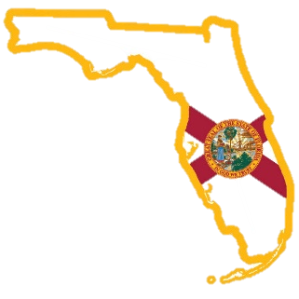

*Visit www.SaveFLVets.org*

**Preventing Suicide Among Service Members, Veterans & Their Families**

**Governor’s Challenge**

**FLORIDA**

Safety Plan Worksheet

**Purpose:** Providers and patients complete Safety Plan together, and patients keep it with them.

 **Step 1. Warning signs** (What are your signs of a crisis? How will know that a Safety Plan should be used):

1. Click or tap here to enter text.
2. Click or tap here to enter text.
3. Click or tap here to enter text.
4. Click or tap here to enter text.

 **Step 2. Internal coping strategies** (What are things you can do to distract yourself from a crisis without contacting others?):

1. Click or tap here to enter text.
2. Click or tap here to enter text.
3. Click or tap here to enter text.
4. Click or tap here to enter text.



 **Step 3. Places and Social Settings** (Where can I go that provides healthy distraction and helps me feel better? My safe places are…):

1. Click or tap here to enter text.
2. Click or tap here to enter text.
3. Click or tap here to enter text.
4. Click or tap here to enter text.

 **Step 4. Social Contacts** (Whose company do I enjoy and makes me feel better? Name 4 people and their phone numbers. Think about co-workers and friends that make you laugh, are great listeners and are compassionate):

1. Click or tap here to enter text.
2. Click or tap here to enter text.
3. Click or tap here to enter text.
4. Click or tap here to enter text.

 **Step 5. Family members or friends who can offer help** (Name 4 responsible relatives and their phone numbers. Consider your spouse, parents, grandparents, siblings, aunts, uncles, best friend and fellow worshipers):

1. Click or tap here to enter text.
2. Click or tap here to enter text.
3. Click or tap here to enter text.
4. Click or tap here to enter text.

 **Step 6. Professionals and agencies to contact for help** (This can include the Veteran Crisis Line, your doctor, or a local emergency department. Also, consider Florida’s Veteran Service Organizations including your County Veteran Service Office (VSO) and local veteran community outreach and centers):

1. Click or tap here to enter text.
2. Click or tap here to enter text.
3. Click or tap here to enter text.
4. Click or tap here to enter text.

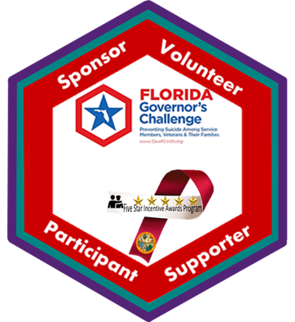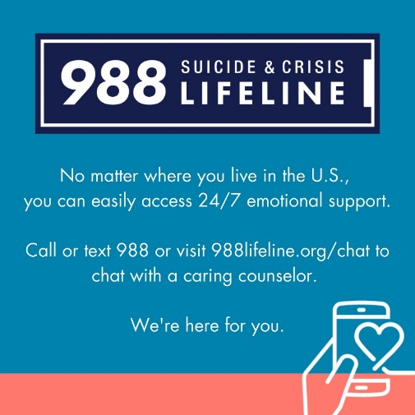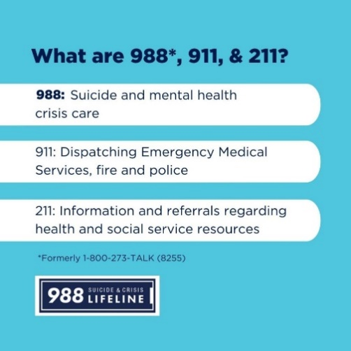

 **Step 7. Making my environment safe** (Plans for removing or limiting access to lethal means):

1. Click or tap here to enter text.
2. Click or tap here to enter text.
3. Click or tap here to enter text.
4. Click or tap here to enter text.

 **Step 8. My reasons for living** (Things that are most important to me and worth living for):

1. Click or tap here to enter text.
2. Click or tap here to enter text.
3. Click or tap here to enter text.
4. Click or tap here to enter text.

